**User Manual**

# LIB’s reports:

* This is one of the most important parts of LIB system.
* This feature supports users collecting and showing data of the system as reports.
* First of all, the librarian will start “Reports Management Feature” by clicking “Reports Management” button as ‘Image 1’.

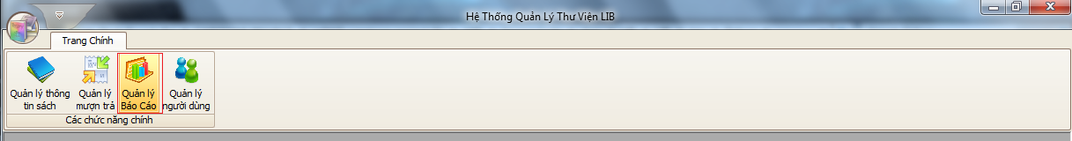

Image 1

* Right after that, user will see a form like ‘Image 2’:

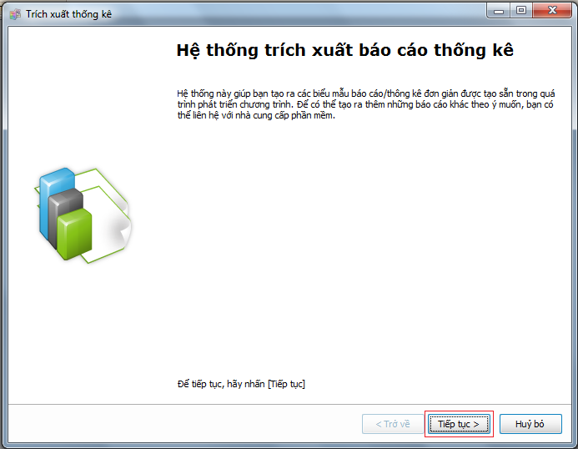

Image 2

* To continue, user just has to click “Next” button.
* Then, next window will be shown (Image 3):

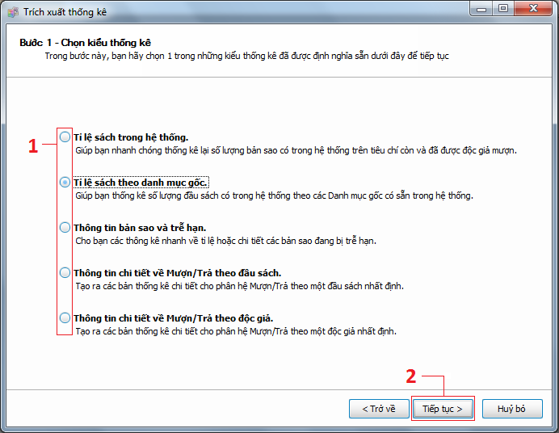

Image 3

* At this step, system requires user to choose one kind of report data. There are 5 kinds including:
  + The ratio of books in system.
  + The ratio of books based on categories.
  + Book copies information and expired rental detail.
  + Rental detail information based on catalogues.
  + Rental detail information based on readers.
* After that, “Next” button needs clicking.

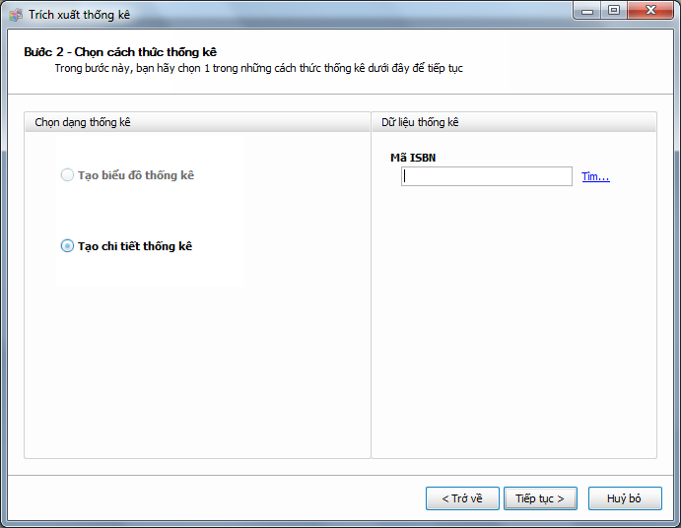

Image 4

* Depends on what kind of report data librarian needs and has chosen before, the out-put reports will have two types of template which she can see their names in the left panel:
  + Showing in detail.
  + Showing in graphs.
  + And in the right side panel, in some cases, user will be required to choose more conditions so that LIB system can find exact result.
* “Next” button clicking will move the current form to next step of this feature.

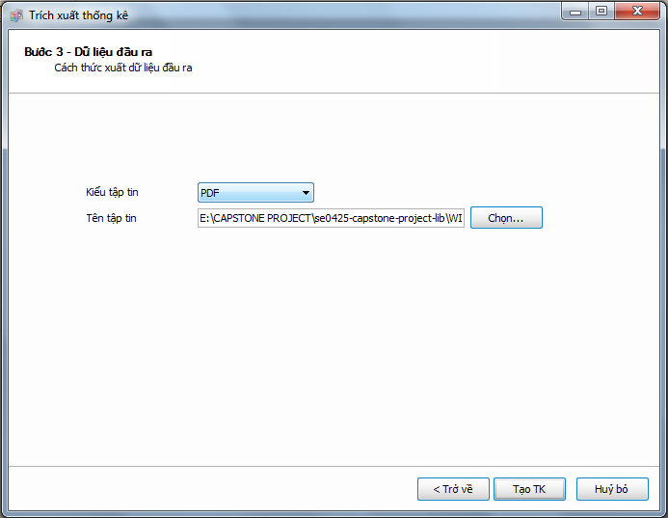

Image 5

* As you can see in ‘Image 5’, you have to choose the output file type for your report. It may be:
  + PDF file
  + Microsoft Excel File
  + An HTML file
* The last thing you must do is choose one place to save this report file to.
* Click at “Create Report” button will start create your report.

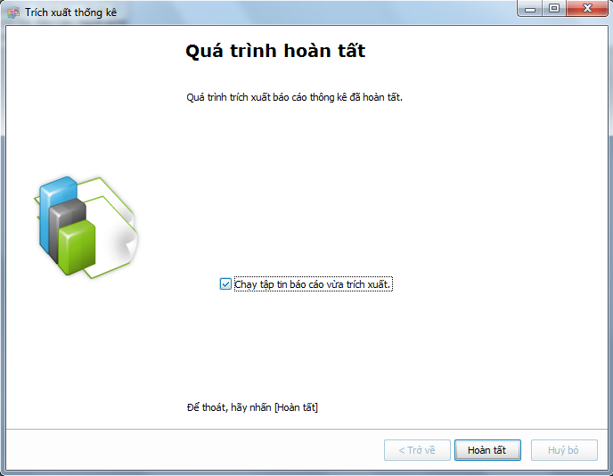

Image 5

* In case you want to view your report immediately, choose at “Run ‘just-created’ report” check-box and click “Finish” button.
* At the end, you will have your report like this if you choose ‘PDF file’.

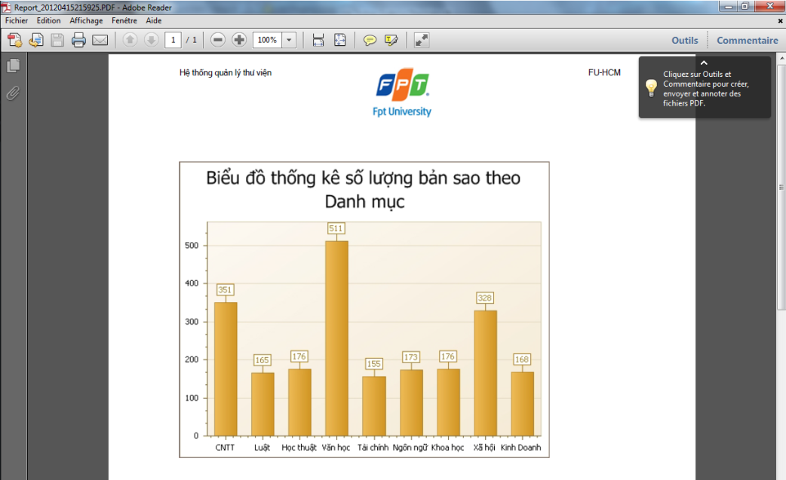

Image 5